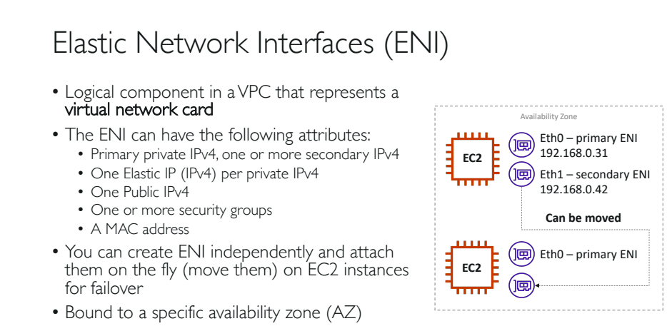

MAC Address and IP Address

|  |  |
| --- | --- |
| **MAC Address** | **IP Address** |
| **Mac address** helps you to identify the device in the local network. | **IP address** helps you to identify the device in the global network. |
| **MAC addresses** can be used for broadcasting. | The **IP address** can be used for broadcasting or multicasting. |

NOTE: The key difference between **broadcast** and **multicast** is that in the **broadcast** the packet is delivered to all the host connected to the network whereas, in **multicast** packet is delivered to intended recipients only. ... However, **multicast** creates less traffic which fasten the system in comparison to **broadcasting**.

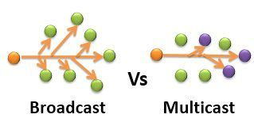

Practice:

1. Launch two new instances which runs on a same availability zone.
2. For this option use Configure Instance>Subnet>Default ap-south-1b from ‘Launch instances’ option.
3. Use existing keypair and launch the instances.
4. Both the newly launched instances will have a new public IPv4 and private address.
5. Select one server and see in the ‘Description> Network interfaces>’ . It will be ‘eth0’ for both.
6. That ‘eth0’ is the primary interface for our instances. And it also represents an interface id like: [eni-025d60fe824f5ff19](https://ap-south-1.console.aws.amazon.com/ec2/v2/home?region=ap-south-1#NIC:search=eni-025d60fe824f5ff19)

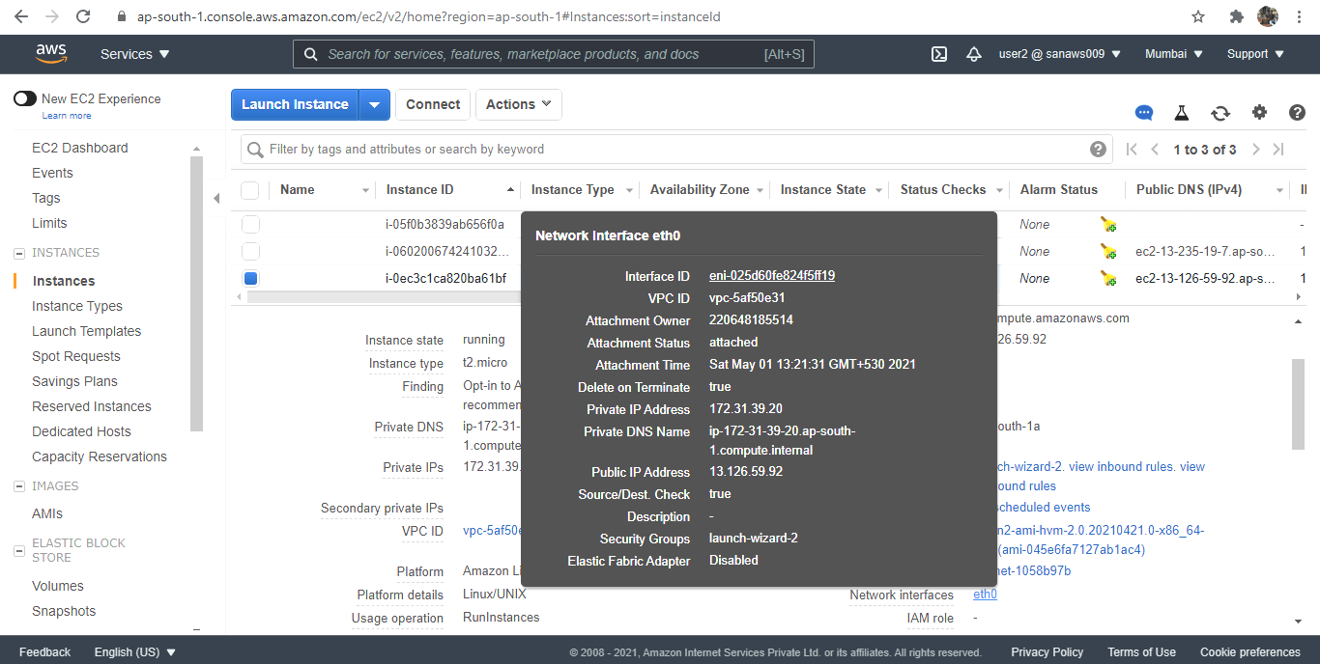

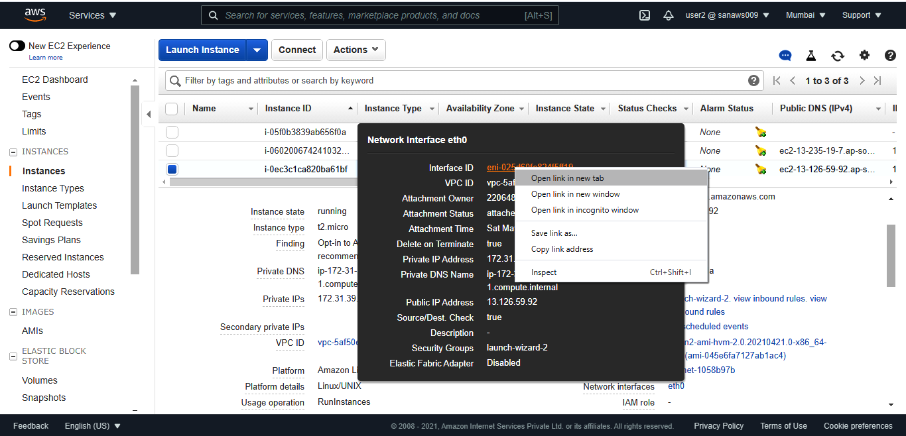

1. Open that interface id in a new tab.
2. Otherwise you could also use ‘Network and Security’ option and select ‘Network Interfaces’.
3. If you observe the status they generally will be ‘in use’.
4. Both the instances have separate public ipv4 and primary private ip addresses.
5. The ‘private primary ips’ are different because they both are attached to two different instances.

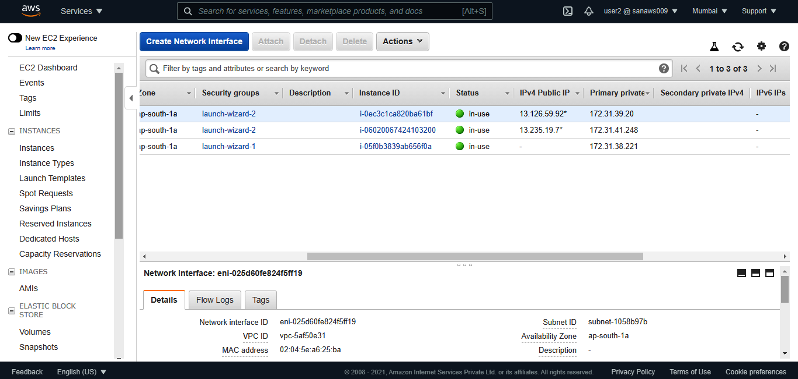

Creating our own network interfaces:

1. Click on ‘Create Network Interface’.
2. Enter description, select ‘subnet’ in the availability zone.
3. Select any security group which is working.
4. Finally click ‘create’ and we can see our new Elastic Network interface.
5. Remove the search filter and we can see all the ENI’s.
6. If you see the status the newly created ENI is in ‘available’ and the other are ‘in use’.
7. Right click on the ‘available’ ENI and click ‘Attach’ to attach it to any instance created.

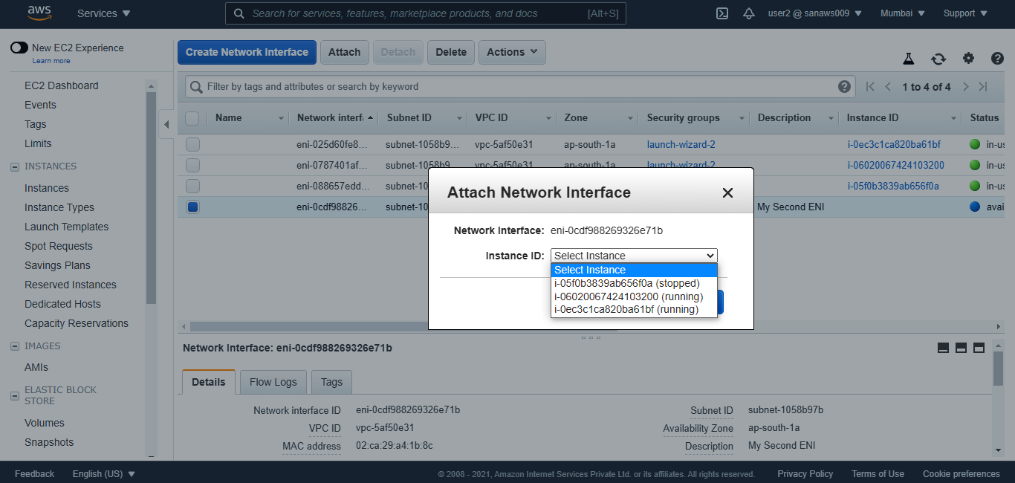

1. The status will be changed to ‘in-use’.
2. Now go to the instances and you can see for one of the newly created instance will have two ‘Network Interfaces’ probable ‘eth0’ and ‘eth1’.

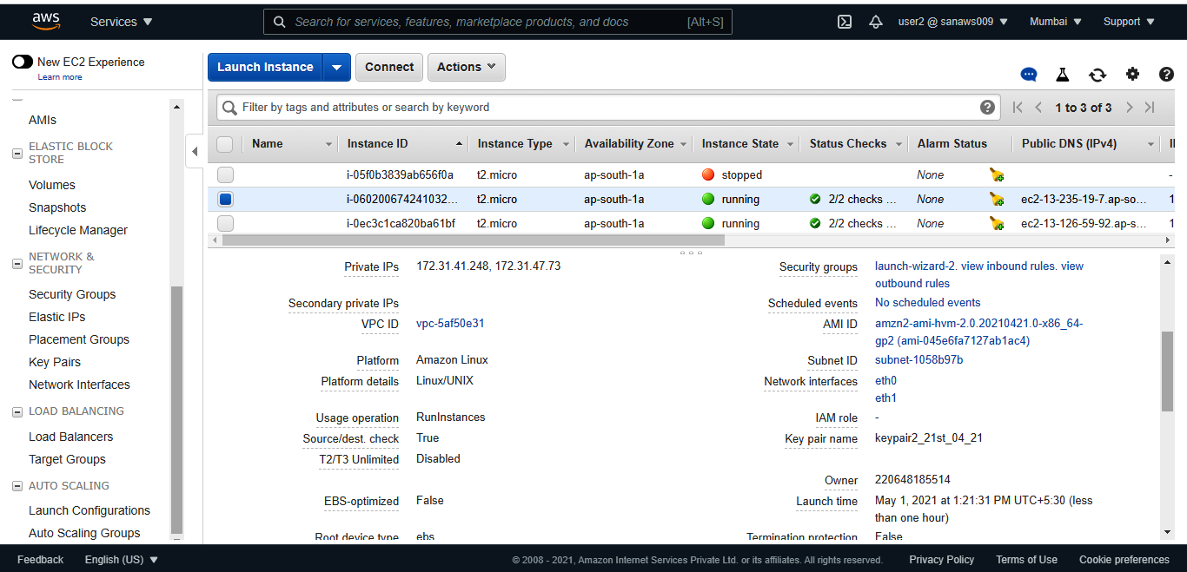

1. First one ‘eth0’ provides us a primary ipv4 address and second one ‘eth1’ provides us seconday ipv4 address.

Moving secondary ENI to our selected instances:

1. Go to network interfaces and ‘Detach’ the ENI from the existing instance.

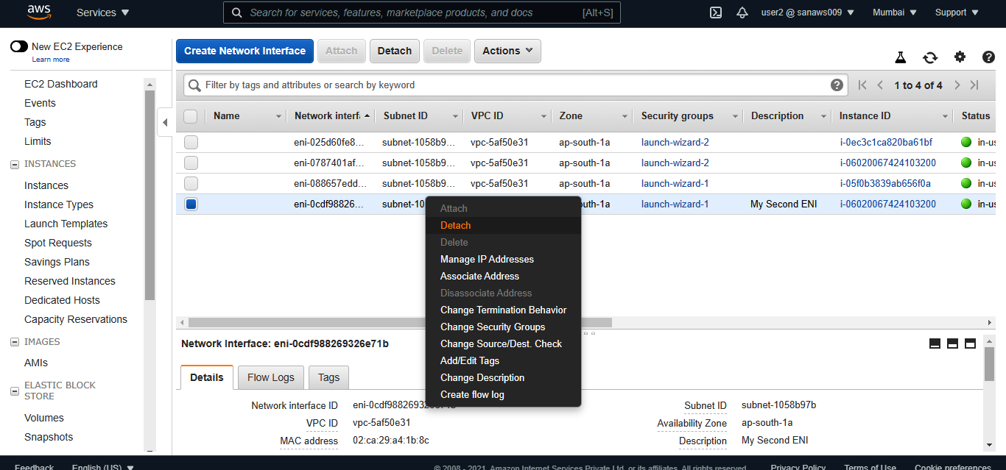

1. Now the status will in ‘available’.
2. Right click on the ENI and attach it to any of your selected instance.
3. Now the status will be ‘in-use’.
4. Go to instances and check for ‘network interfaces’ in ‘description’ for the newly attached instance.

NOTE: After ENI practice is complete detach the ENI and terminate your instances(newly created for ENI).